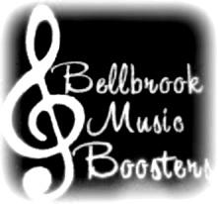
Bellbrook Music Boosters

Executive Booster Meeting Minutes
Monday, Dec 5, 2016
6:15pm
BHS Library

The meeting was called to order at 6:15pm by President, Tamara Cary.
In attendance: Tamara Cary, Dan Miller, Lindy Sparrow, Jen Huff, Tracey Waller, Joy Jones, Barb Siler, Chris Foster, John Withrow, Kella Looney

The Executive Membership heard a report or acted upon the following:
- Approved Nov minutes (motion Lindy, second John, all approved)
- President’s Report
  - Scholarships for Winter – review of submissions was completed; board approved (motion Tracey, Second Kella, all approved of decisions)
  - Winter program fee schedule has been decided, commitment fee due on 12/9 and final payment by 1/27
  - Survey results/answers – quick review of the responses to the survey
- VP Report
  - Credit card payments and donations is active on the Music website
- Treasurer
  - Hold for General Meeting
- Board of Trustee’s Report
  - Sponsorship, Miller – end of year push; including a day of giving option on website
- Director’s Report
  - Hold for General meeting
- Old Business
- New Business
  - IPE MEPA and MSBA program fees were paid to each organization for 2017

Adjournment at 7:13pm, motion Lindy and second Kella
Next Executive Booster Meeting:
Monday, January 9th
6:15pm, BHS Library

